**Redis,zookeeper线上集群部署文档**

# 1、概述

1. 根据现有数据量,redis需要两台64G左右大内存物理机,考虑到以后数据扩容每台redis服务器上部署4个redis实例,如以后数据量飙升到达redis物理服务器内存最大值,可以把redis服务器实例迁移到其他物理机上.
2. 由于现在redis不支持集群,采用zookeeper检测redis实例,建议zookeeper部署到三台物理机上,可以考虑和其他应用共用物理机.
3. zookeeper需要部署到安装jdk机器上.
4. Redis部署图如下:

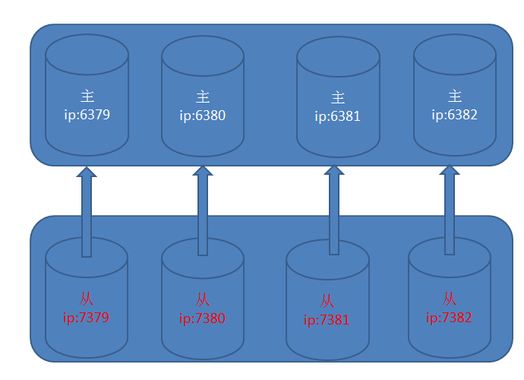

# 2、redis主搭建

1,下载redis-2.8.9.tar.gz,也可从邮件附件中获取

2,解压,解压完毕进去redis目录执行make命令

3,将邮件附件中的redis6379.conf, redis6380.conf, redis6381.conf, redis6382.conf四个文件拷贝的conf目录下

4,在linux下分别建立如下文件

**创建pid**

|  |
| --- |
| vi /var/run/redis6379.pid |
| vi /var/run/redis6380.pid |
| vi /var/run/redis6381.pid |
| vi /var/run/redis6381.pid |

**创建log文件**

|  |
| --- |
| vi /opt/logs/redis/redis6379.log |
| vi /opt/logs/redis/redis6380.log |
| vi /opt/logs/redis/redis6381.log |
| vi /opt/logs/redis/redis6382.log |

**创建data路径**

|  |
| --- |
| mkdir -p /opt/data/redis6379 |
| mkdir -p /opt/data/redis6380 |
| mkdir -p /opt/data/redis6381 |
| mkdir -p /opt/data/redis6382 |

**5,启动redis**

进入src目录 分别执行

|  |
| --- |
| /usr/local/redis/redis-2.8.9/src/redis-server /usr/local/redis/redis-2.8.9/redis6379.conf |
| /usr/local/redis/redis-2.8.9/src/redis-server /usr/local/redis/redis-2.8.9/redis6380.conf |
| /usr/local/redis/redis-2.8.9/src/redis-server /usr/local/redis/redis-2.8.9/redis6381.conf |
| /usr/local/redis/redis-2.8.9/src/redis-server /usr/local/redis/redis-2.8.9/redis6382.conf |

# 3、redis从搭建

1,前两个步骤一致

3,将邮件附件中的redis7379.conf, redis7380.conf, redis7381.conf, redis7382.conf四个文件拷贝的conf目录下

4,在linux下分别建立如下文件

**创建pid**

|  |
| --- |
| vi /var/run/redis7379.pid |
| vi /var/run/redis7380.pid |
| vi /var/run/redis7381.pid |
| vi /var/run/redis7381.pid |

**创建log文件**

|  |
| --- |
| vi /opt/logs/redis/redis7379.log |
| vi /opt/logs/redis/redis7380.log |
| vi /opt/logs/redis/redis7381.log |
| vi /opt/logs/redis/redis7382.log |

**创建data路径**

|  |
| --- |
| mkdir -p /opt/data/redis7379 |
| mkdir -p /opt/data/redis7380 |
| mkdir -p /opt/data/redis7381 |
| mkdir -p /opt/data/redis7382 |

**5,启动redis**

进入src目录 分别执行

|  |
| --- |
| /usr/local/redis/redis-2.8.9/src/redis-server /usr/local/redis/redis-2.8.9/redis7379.conf |
| /usr/local/redis/redis-2.8.9/src/redis-server /usr/local/redis/redis-2.8.9/redis7380.conf |
| /usr/local/redis/redis-2.8.9/src/redis-server /usr/local/redis/redis-2.8.9/redis7381.conf |
| /usr/local/redis/redis-2.8.9/src/redis-server /usr/local/redis/redis-2.8.9/redis7382.conf |

**6,设置主从**

在src目录下分别执行如下命令

./redis-cli -p 7379

SLAVEOF 主ip 端口

info 查看主从设置是否正确,如下则正确

role:slave

master_host:主ip地址

master_port:6379

如下设置：

|  |
| --- |
| [root@Mobo6 src]# ./redis-cli -p 7379 |
| 127.0.0.1:7379> SLAVEOF 10.127.3.218 6379 |
| OK |
| 127.0.0.1:7379> info |
| # Replication  role:slave  master_host:10.127.3.218  master_port:6379 |

//////////////////////////////////////////////

./redis-cli -p 7380

SLAVEOF 主ip 6380

info 查看主从设置是否正确,如下则正确

role:slave

master_host:主ip地址

master_port:6380

设置如7379。

//////////////////////////////////////////////

./redis-cli -p 7381

SLAVEOF 主ip 6381

info 查看主从设置是否正确,如下则正确

role:slave

master_host:主ip地址

master_port:6381

设置如7379。

/////////////////////////////////////////////////

./redis-cli -p 7382

SLAVEOF 主ip 6382

info 查看主从设置是否正确,如下则正确

role:slave

master_host:主ip地址

master_port:6382

设置如7379。

**三,zookeeper集群部署步骤**

1,下载zookeeper-3.4.6.tar.gz

|  |
| --- |
| wget http://mirrors.cnnic.cn/apache/zookeeper/zookeeper-3.4.6/zookeeper-3.4.6.tar.gz |

2,解压

|  |
| --- |
| tar -zxvf zookeeper-3.4.6.tar.gz |

3,如果zookeeper安装目录如下

|  |
| --- |
| /usr/local/redis/zookeeper |

在该目录下建立data文件夹,假设有三台zookeeper机器,ip分别为A,B,C则

|  |
| --- |
| mkdir –p /usr/local/redis/zookeeper/data |
| vi /usr/local/redis/zookeeper/data/myid |

A机器目录/home/mobileweb/zookeeper/data下建myid文件内容为1

B机器目录/home/mobileweb/zookeeper/data下建myid文件内容为2

C机器目录/home/mobileweb/zookeeper/data下建myid文件内容为3

A,B,C机器zoo.cfg文件内容为:

tickTime=5000

initLimit=10

syncLimit=5

dataDir=/home/mobileweb/zookeeper/data

clientPort=2181

server.1=10.127.3.218:2888:3888

server.2=B:2889:3889

server.3=C:2890:3890

4,启动

进入各自安装bin目录下分别执行./zkServer.sh start zoo.zfg 启动zookeeper服务

|  |
| --- |
| /usr/local/redis/zookeeper/bin/zkServer.sh start ../conf/zoo.cfg |

5,链接到其中一台zookeeper服务器

|  |
| --- |
| /usr/local/redis/zookeeper/bin/zkCli.sh -server 10.127.3.218:2181 |

分别执行如下命令

创建zookeeper节点

|  |
| --- |
| create /mobile aaa |

设置zookeeper监控节点

|  |
| --- |
| set /mobile {'maxActive':1000,'maxWait':5000,'maxIdle':50,'masterConfString':'10.127.3.218:6379,10.127.3.218:6380,10.127.3.218:6381,10.127.3.218:6382','slaveConfString':'10.127.3.218:7379,10.127.3.218:7380,10.127.3.218:7381,10.127.3.218:7382'} |

确认值已经正确赋值

|  |
| --- |
| get /mobile |